**greenthom - 300536064**

**ENGR110 Machine Learning Lab 1**

**Exercise 1:**

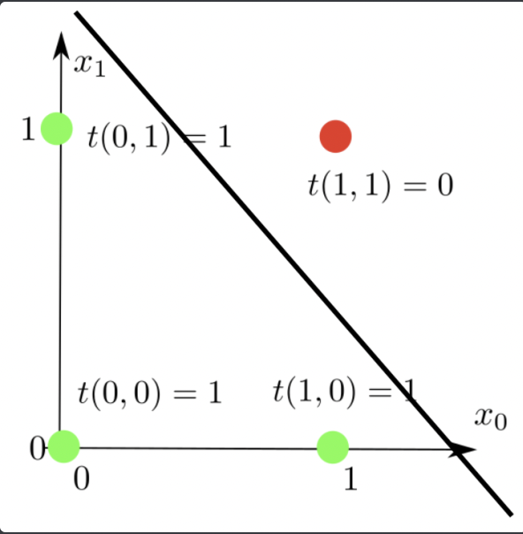

**Exercise 2:**

The combination is determined through the sigmoid function:

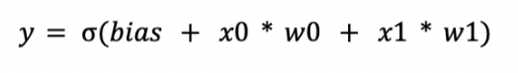

**Whatever combination of biases the functions W0 and W1, provide the value that is nearest to zero. These are the ideal values given as this graph is symmetrical. In this situation, 0,1 and 1.0 we want to give 1, which means we want a perfect 45-degree line which crosses the W0 and W1 values, which leads the bias to shift the sloped line.**

**Neuron is passed through reference. Since it being a large object composing a vector with few other values. Instead of copying the value it is easier to copy the address.**

**Exercise 4**

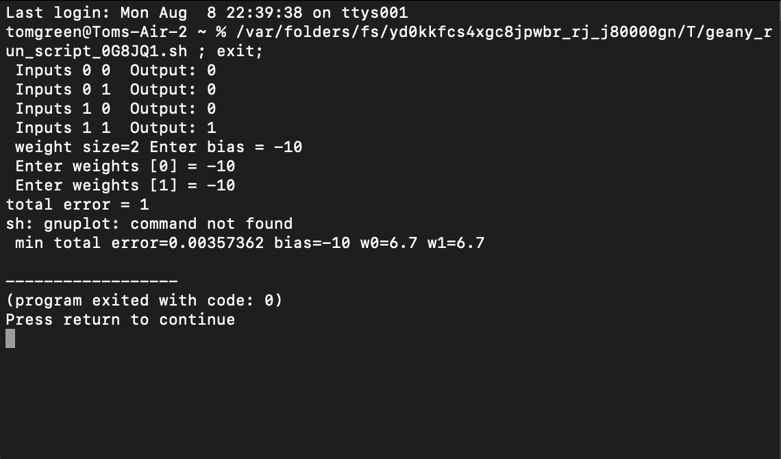

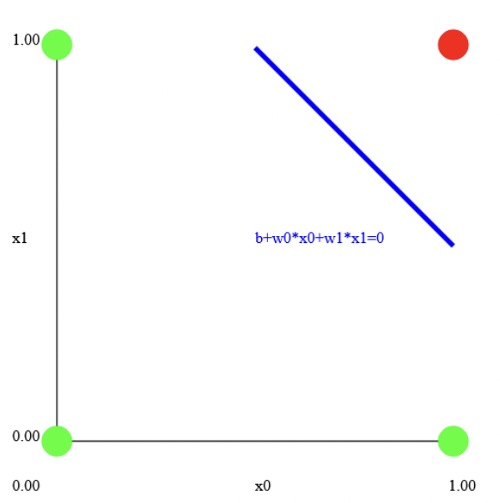

**Exercise 6**

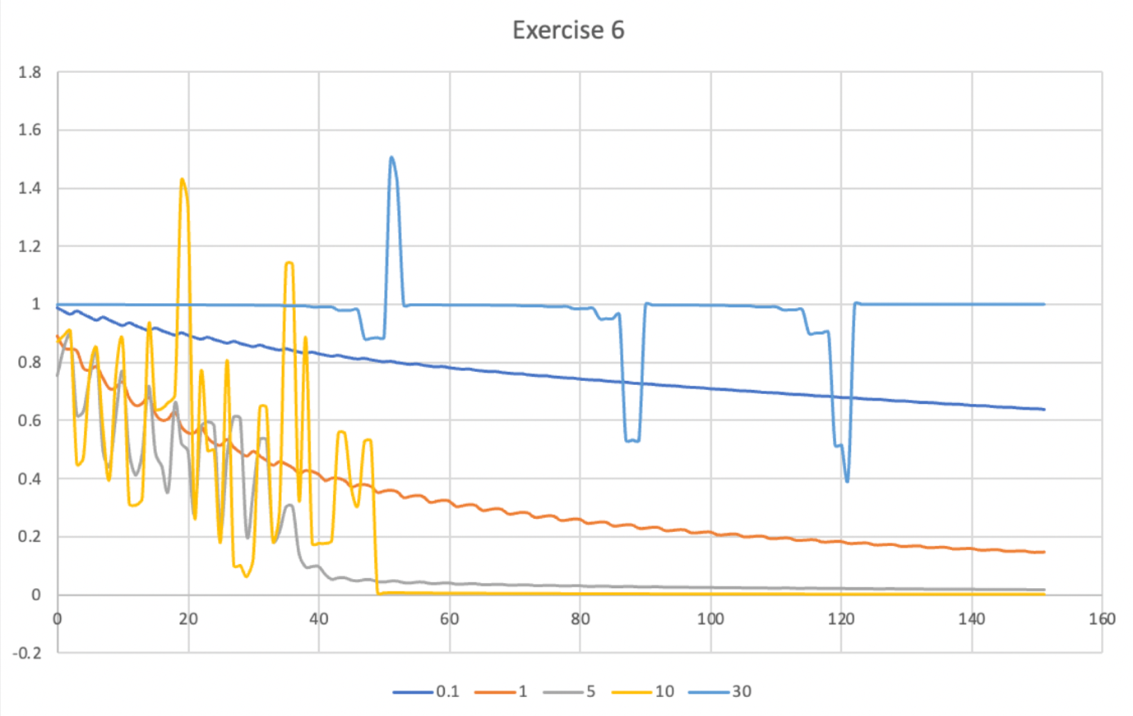

**The learning rate is a constant value that the step/error value is multiplied, which determines how fast the Neural Net goes downhill trying to reduce the error. The error can go up and down during training if the overall trend is moving downwards.**

**We used 5 different learning rates: 0.1, 1.0, 5.0, 10.0, 30.0,**

**We ran searches, saving convergence each time. What reflected through this search showed that small learning rate resulted in a small step and large learning rate resulted in a large step. If the learning rate was small, the algorithm would step carefully but would take many steps which resulted in too much time to find the result. If the learning rate was too high it would step too far which causes it to be inaccurate but could take less time to find the result.**

**At learn rate value 0.1 the line has a downward trend but not very steep. At learn rate 1.0 the line has a downward trend however goes down by much more producing an error rate that is much closer to zero. At learn rate value 5.0, the error is up and down but results a final error that is very close to 0. At learn rate value 10.0, the error shows an unstable up and down figure but produces the error closest to zero. Either learn rate 5.0 or 10.0 would be best to balance out the learning rates, and despite 10.0 being more volatile, its error value is more ideal.**